**NAME**: - Jaydeep Solanki

**ROLL NO**: - 22ECG060 | 22BEC059

**COURSE CODE**: - 1CS501

**SUBJECT**: - COMPUTER PROGRAMMING

**PRACTICAL NO 3:**  C programs to demonstrate use of conditional statements for following problem statements.

1. Write a program to take the values for A, B, C of a quadratic equation A∗X2+B∗X+C=0 and then find all the roots of the equation. It is guaranteed that A≠ 0 and that the equation has at least one real root.

**Code :**

#include <math.h>

#include <stdio.h>

int main()

{

int a, b, c, d, one_value, second_value;

printf("Please specify the value of A :");

scanf("%d", &a);

printf("Please specify the value of B :");

scanf("%d", &b);

printf("Please specify the value of C :");

scanf("%d", &c);

printf("Quadratic equation is : %d X^2 + %dX + %d\n", a, b, c);

d = ((b * b) - 4 * a * c);

one_value = ((-b) + sqrt('d')) / 2 * a;

second_value = ((-b) - sqrt('d')) / 2 * a;

printf("The two roots of this equation are \n1. %d\n2. %d", one_value,

second_value);

}

**Output:**

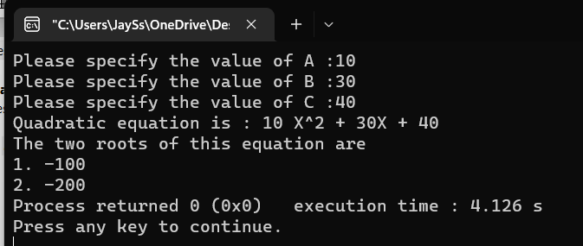

1. Write a program that prints a table of all the Roman-numeral equivalents of the decimal numbers in the range 1 to 100.

**Code:**

#include <stdio.h>

int main() {

int n;

printf("Decimal Roman\n");

printf("-------------------\n");

for (int i = 1; i <= 100; i++) {

n = i;

printf(" %d ", i);

while (n != 0) {

if (n >= 100) {

printf("C");

n -= 100;

} else if (n >= 90) {

printf("XC");

n -= 90;

} else if (n >= 50) {

printf("L");

n -= 50;

} else if (n >= 40) {

printf("XL");

n -= 40;

} else if (n >= 10) {

printf("X");

n -= 10;

} else if (n >= 9) {

printf("IX");

n -= 9;

} else if (n >= 5) {

printf("V");

n -= 5;

} else if (n >= 4) {

printf("IV");

n -= 4;

} else if (n >= 1) {

printf("I");

n -= 1;

}

}

printf("\n");

}

return 0;

}

**Output:**

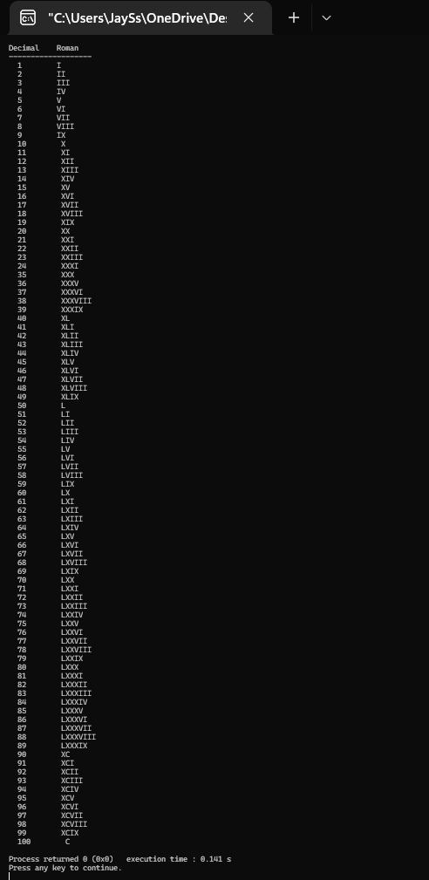



1. In an organization, employees are paid on hourly basis. Clerks are paid 100/hr, Teachers are paid 200/hr and Principal is paid 400/hr. If the weekly hours exceed 44, then employee should be paid 2 times their regular pay for the overtime. Write a C program to compute the weekly salary of the employee and also the program should take care that the employee should not be paid for hours beyond 50 in a week. Use best suitable control construct to implement the program.

**Code:**

#include <stdio.h>

int main() {

int clerk, working_hours, teacher, principal;

int whom;

clerk = 100;

teacher = 200;

principal = 400;

printf("Whom you want to compute the weekly salary "

"?\n1.clerk\n2.teacher\n3.principal\n : ");

scanf("%d", &whom);

int amount;

if (whom == 1) {

amount = clerk;

} else if (whom == 2) {

amount = teacher;

} else {

amount = principal;

}

printf("The number of hours the employee worked : ");

scanf("%d", &working_hours);

if (working_hours > 50) {

printf("The salay of the employee will be %d ",

amount * 44 + 6 * 2 * amount);

} else {

if (working_hours > 44) {

int extra_salary;

extra_salary = working_hours - 44;

printf("The salary of the employee will be %d",

amount * 44 + extra_salary * 2 * amount);

} else {

printf("The salary of the employee will be %d", amount * working_hours);

}

}

}

**Output:**

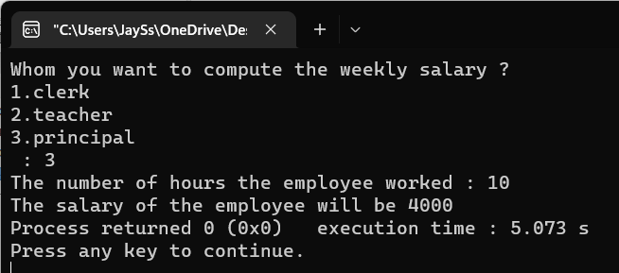

1. Ajay and Amit are playing a game with a number X. In one turn, they can multiply X by 2. The goal of the game is to make X divisible by 10. Write a C program to find the number of turns necessary to win the game (it may be possible to win in zero turn, 1 turn or it might be impossible (-1 turns)).

**Code:**

#include <stdio.h>

int main() {

int number;

printf("Enter the value of X : ");

scanf("%d", &number);

if (number % 10 == 0 || number % 5 == 0) {

printf("The value of x is divisible by 10");

} else if (number * 2 % 10 == 0 || number * 2 % 5 == 0) {

printf("The value of x is divisible by 10");

} else {

printf("Loser ");

}

return 0;

}

**Output:**

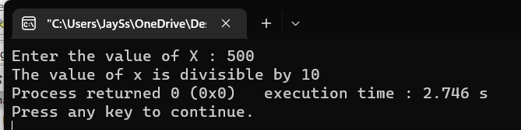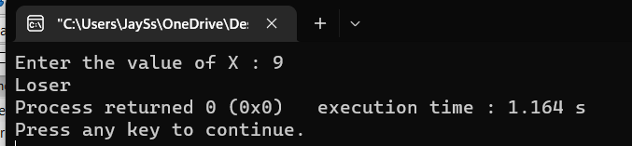

1. Write a program to implement a simple number guessing game. Program should generate an integer randomly and ask the user to guess the integer. Based on the number guessed, it should display the appropriate message (correct or incorrect).

**Code:**

#include <stdio.h>

int main() {

srand(time(NULL));

int num = rand() % 100 + 1;

int guess;

printf("Guess a number between 0 and 100: ");

scanf("%d", &guess);

if (guess == num) {

printf("You guessed it right!\n");

} else {

printf("You guessed wrong!\nThe number was %d",num);

}

}

**Output:**

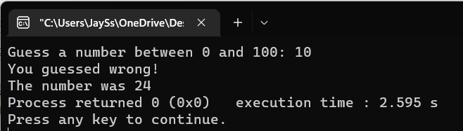

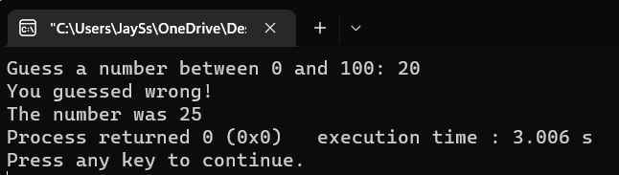

1. Write a C program to find the grade of a student based on the following policy.

Class test: 12% weightage, Tutorial-12%, SE:16%, LPW:20%, SEE:40%.

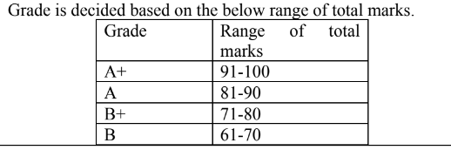

**Code:**

#include <stdio.h>

int main() {

float ct, t, se, lpw, see, ct1, t1, se1, lpw1, see1, total_marks;

printf("Enter class test marks:");

scanf("%f", &ct);

printf("Enter tutorial marks:");

scanf("%f", &t);

printf("Enter SE marks:");

scanf("%f", &se);

printf("Enter LPW marks:");

scanf("%f", &lpw);

printf("Enter SEE marks:");

scanf("%f", &see);

ct1 = ct * 0.12;

t1 = t * 0.12;

se1 = se * 0.16;

lpw1 = lpw * 0.2;

see1 = see * 0.4;

total_marks = ct1 + t1 + se1 + lpw1 + see1;

printf("Your marks are :- %f\n\n", total_marks);

if (total_marks > 90 && total_marks <= 100) {

printf("Your grade is A+");

} else if (total_marks > 80 && total_marks <= 90) {

printf("Your grade is A");

} else if (total_marks > 70 && total_marks <= 80) {

printf("Your grade is B+");

} else if (total_marks > 60 && total_marks <= 70) {

printf("Your grade is B");

} else if (total_marks > 50 && total_marks <= 60) {

printf("Your grade is C+");

} else if (total_marks > 40 && total_marks <= 50) {

printf("Your grade is C");

} else if (total_marks < 40) {

printf("Your grade is Fail !");

} else {

printf("There is some error in grading system !");

}

}

**Output:**

